# Project Report - Blog Application

## Personal Details

Name: **Beetupalli Chaitanya Prasad**

Email ID: **chaydia6666@gmail.com**

Batch Code: **Java J2EE - 27 Feb Batch**

Superset ID: **4626384**

Project Title: **Blog Application - RESTful API**

Date: 25-03-2025

## Project Abstract

This Blog Application is a RESTful API developed using Spring Boot and MySQL.  
It allows users to create, retrieve, update, and delete blog posts, as well as post comments.  
The project follows MVC architecture and incorporates best practices such as DTOs, exception handling, and validation mechanisms.

## Technologies Used

- Spring Boot (Java Framework)  
- Spring Data JPA (Database Handling)  
- MySQL (Database Management)  
- Swagger API (API Documentation & Testing)  
- Maven (Build & Dependency Management)  
- Git & GitHub (Version Control)

## API Endpoints and Testing

The following API endpoints have been implemented and tested using Swagger API:  
1. Create Blog (POST /api/blogs) - Adds a new blog post.  
2. Get Blog By ID (GET /api/blogs/{id}) - Retrieves a blog by its ID.  
3. Update Blog (PUT /api/blogs/{id}) - Updates an existing blog post.  
4. Delete Blog (DELETE /api/blogs/{id}) - Deletes a blog post.  
5. Get All Blogs (GET /api/blogs) - Fetches all blogs.  
6. Post Comment (POST /api/blogs/comment) - Adds a comment to a blog.  
7. Get Comments (GET /api/blogs/comment?blogId={id}) - Retrieves comments for a blog.

8. Get All Comments Based on Blog Id (GET / api/blogs/{blogsId}/comments ( Optional)

**Screenshots of Swagger API responses for positive and negative test cases are provided in the following pages.**

## Swagger API Screenshots – Positive Test Cases

**1. Create Blog (POST /api/blogs) - Adds a new blog post.**

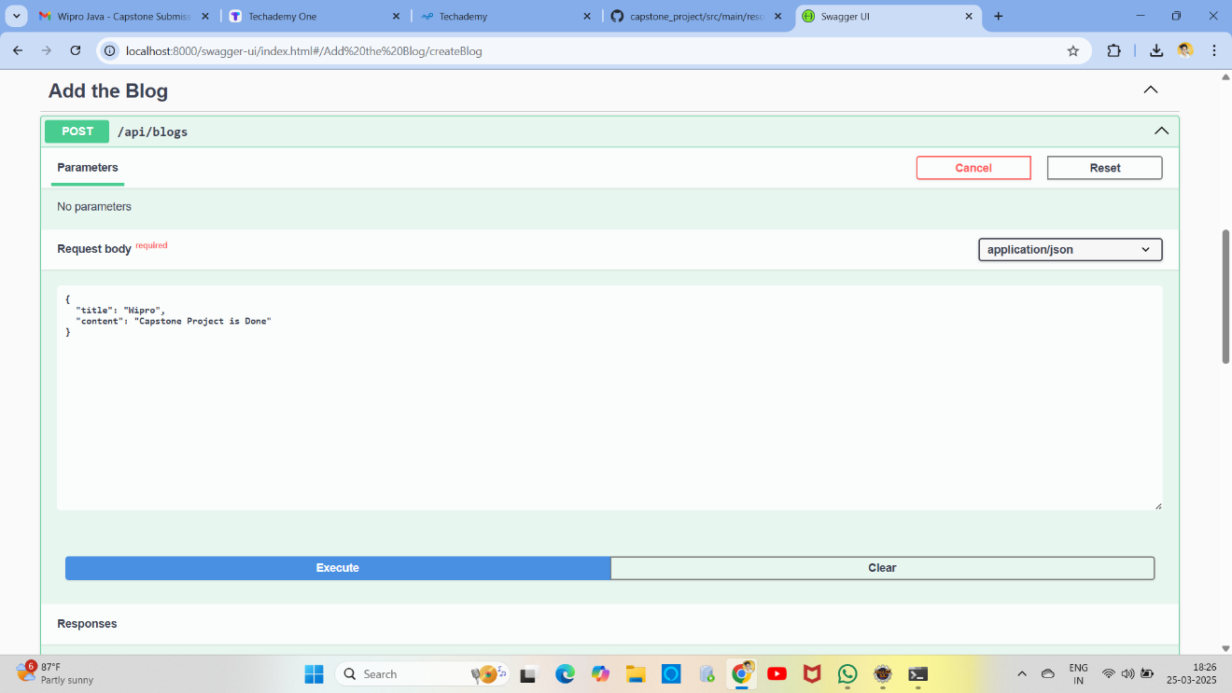

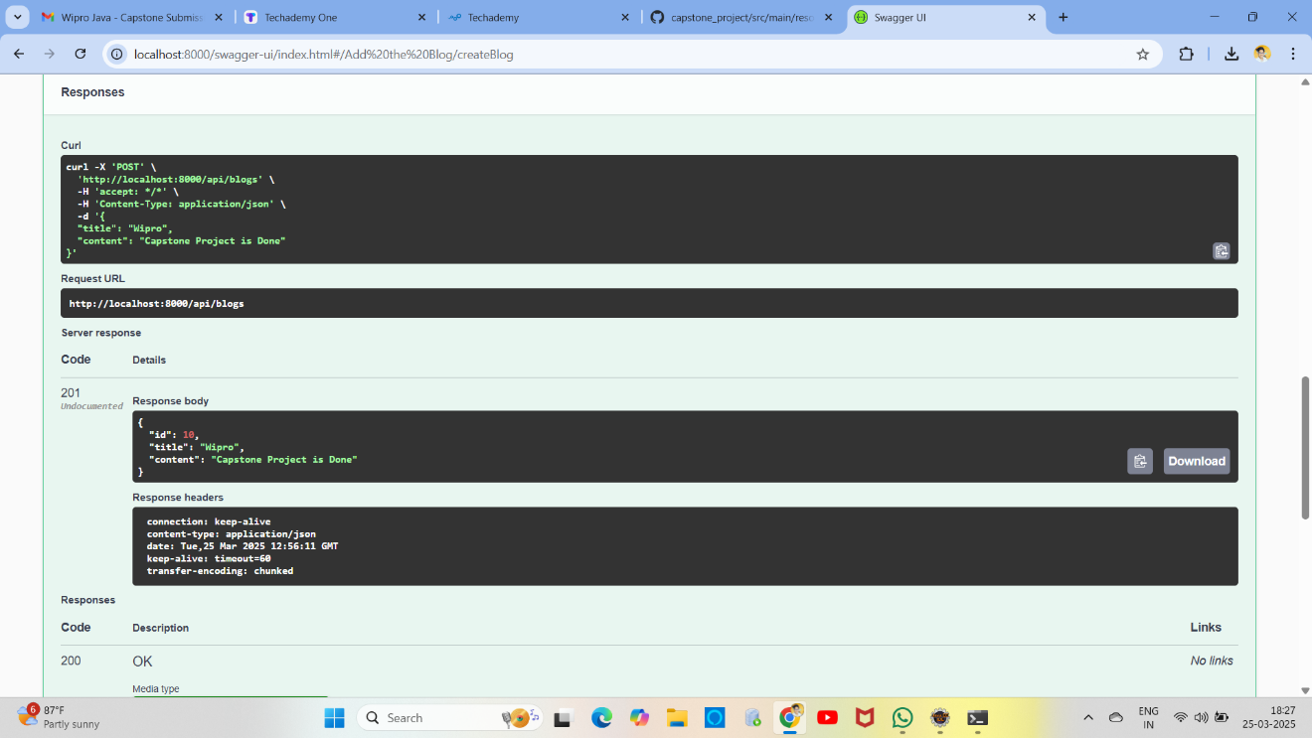

**2. Get Blog By ID (GET /api/blogs/{id}) - Retrieves a blog by its ID.**

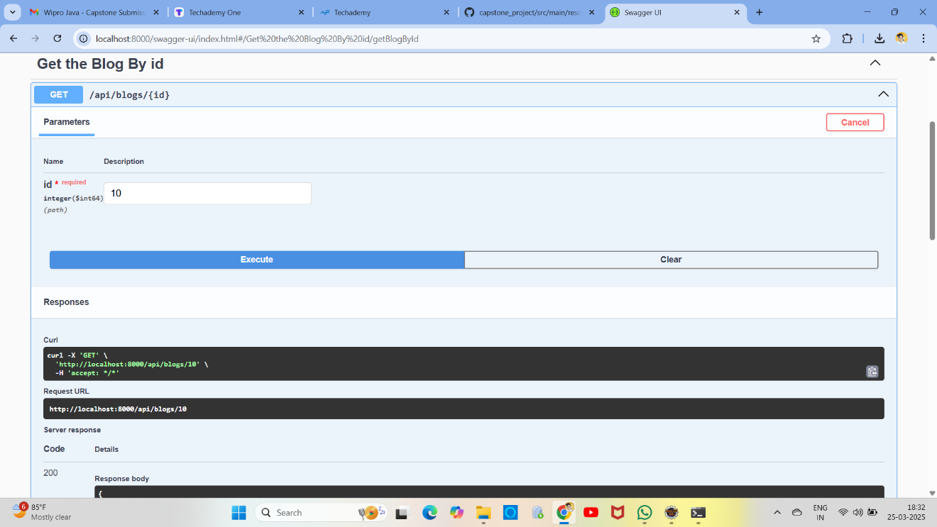

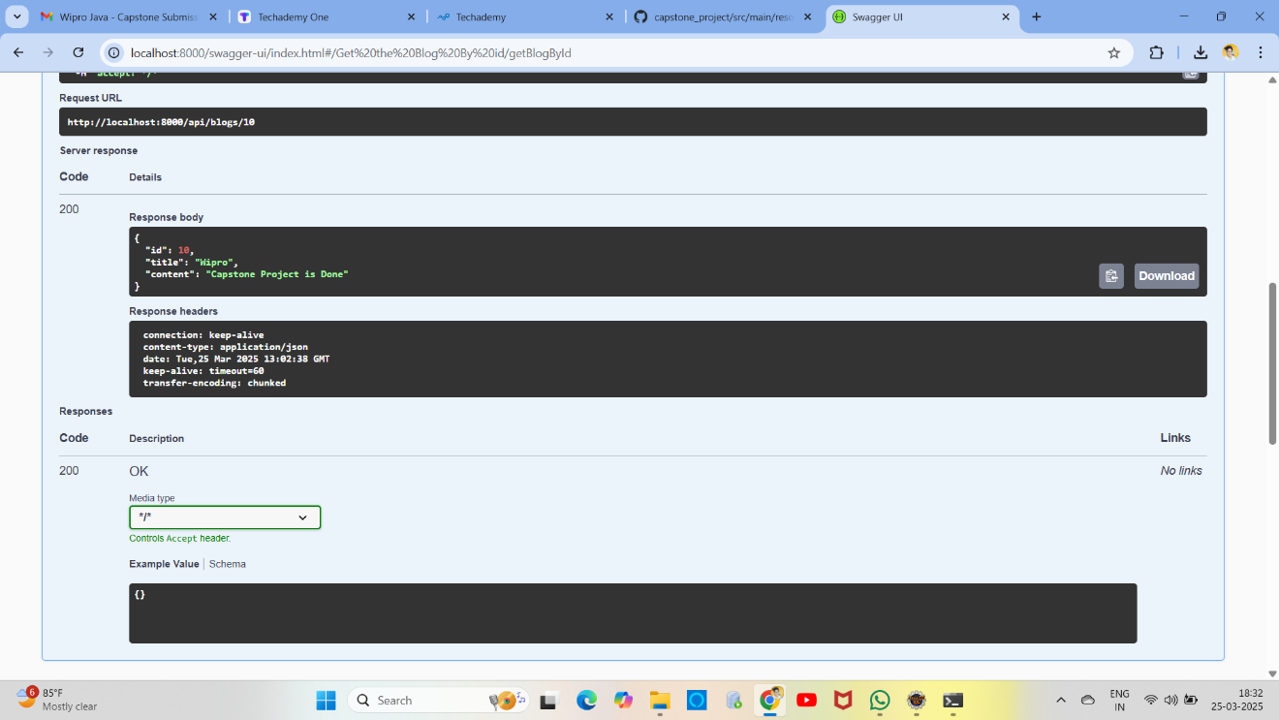

**3. Update Blog (PUT /api/blogs/{id}) - Updates an existing blog post.**

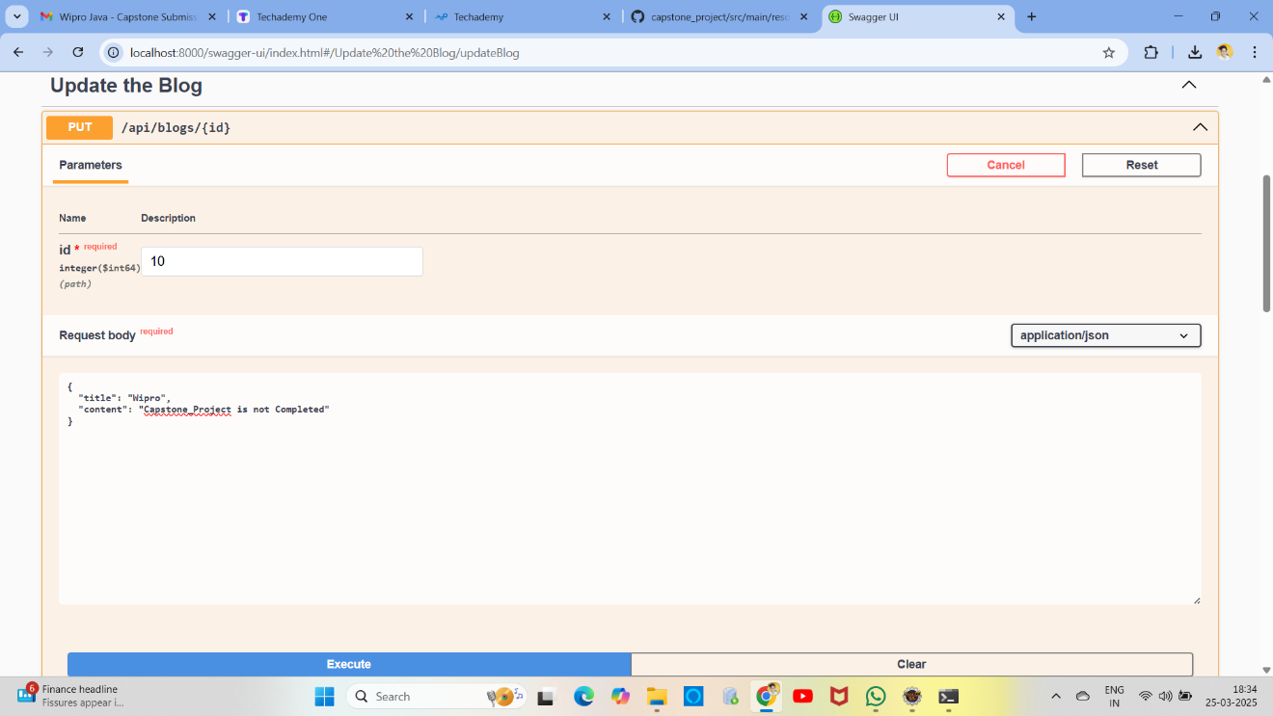

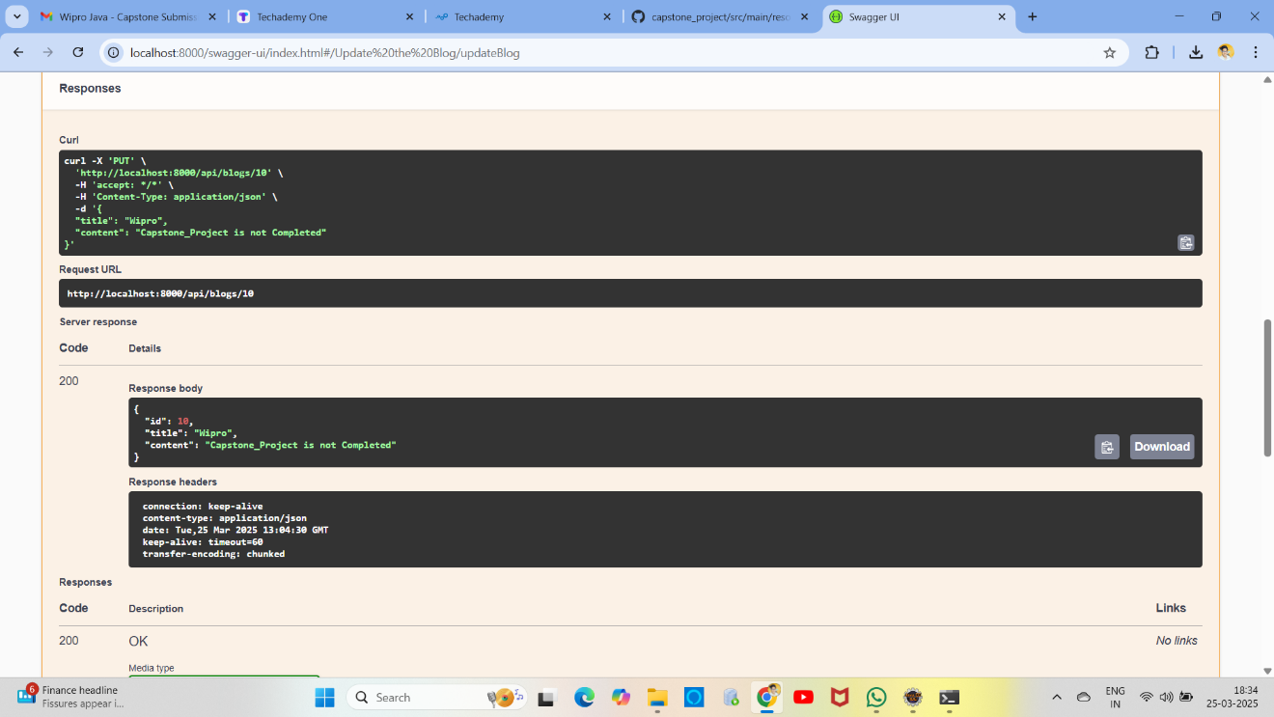

**4. Delete Blog (DELETE /api/blogs/{id}) - Deletes a blog post.**

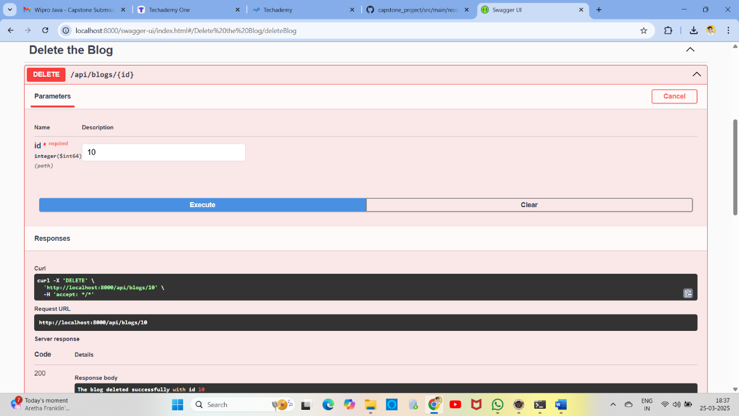

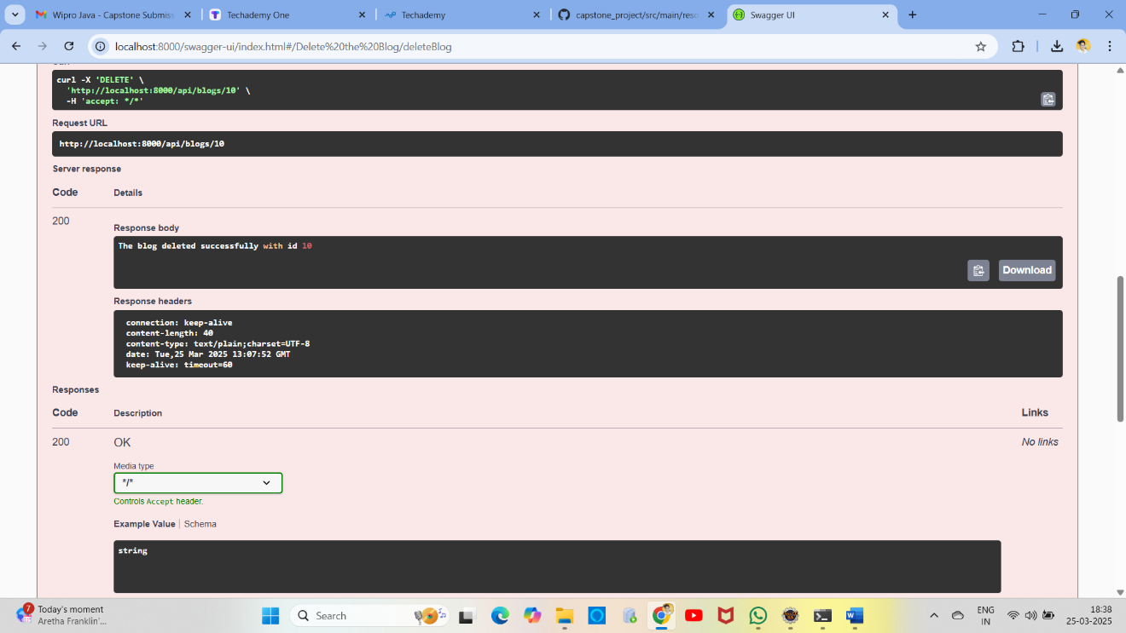

**5. Get All Blogs (GET /api/blogs) - Fetches all blogs.**

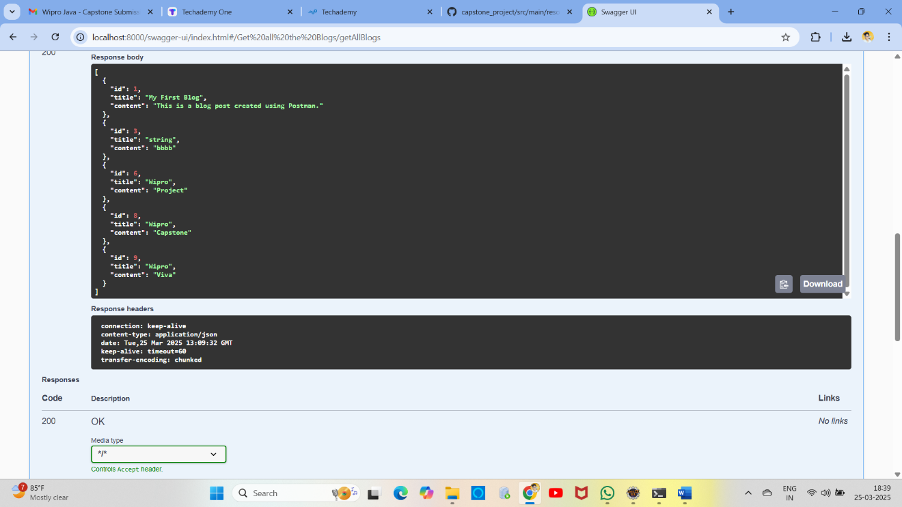

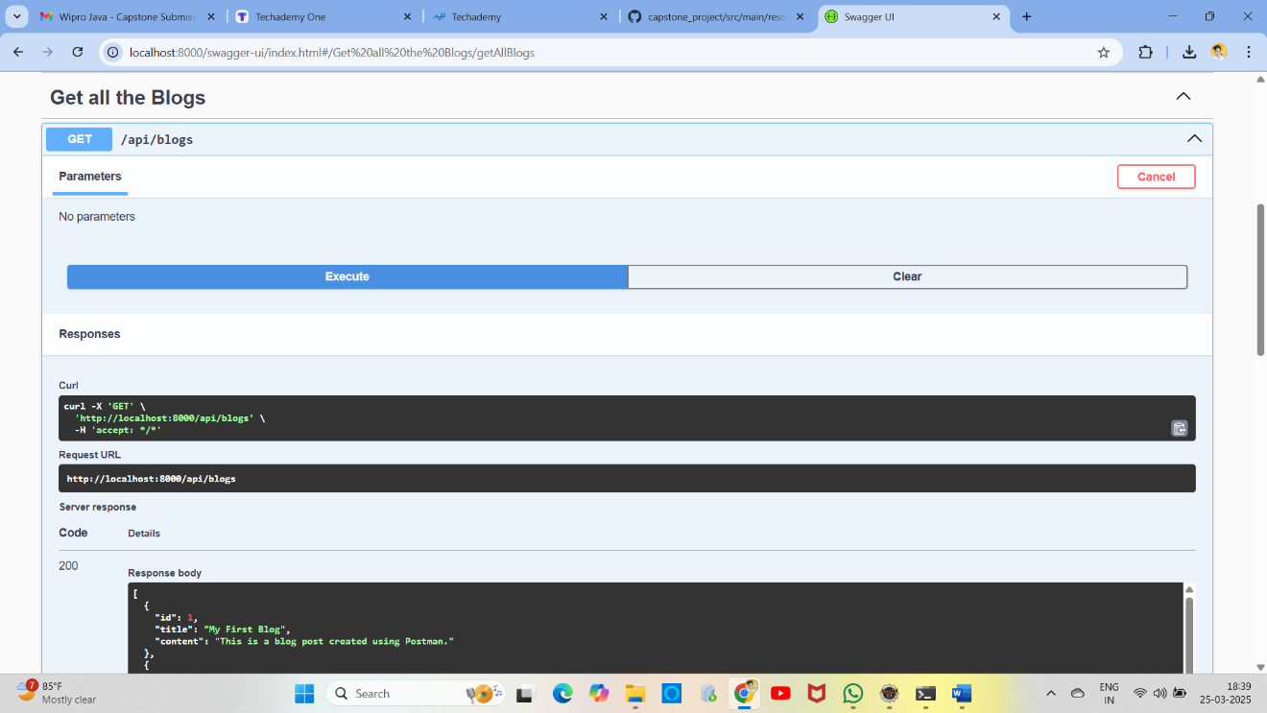

**6. Post Comment (POST /api/blogs/comment) - Adds a comment to a blog.**

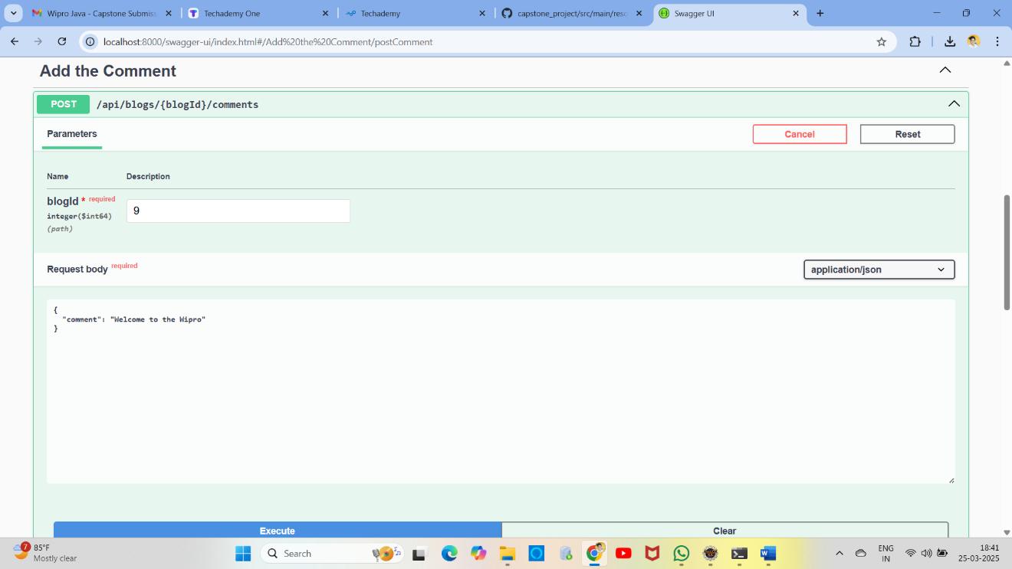

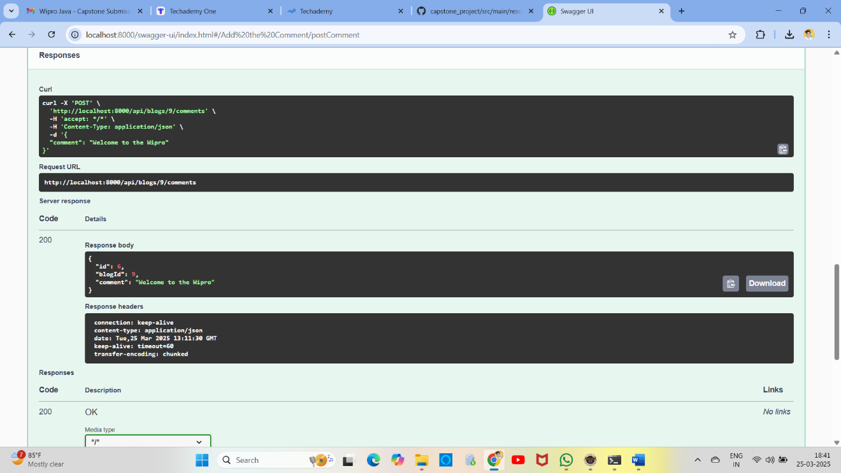

**7. Get Comments (GET /api/blogs/comment?blogId={id}) - Retrieves comments for a blog.**

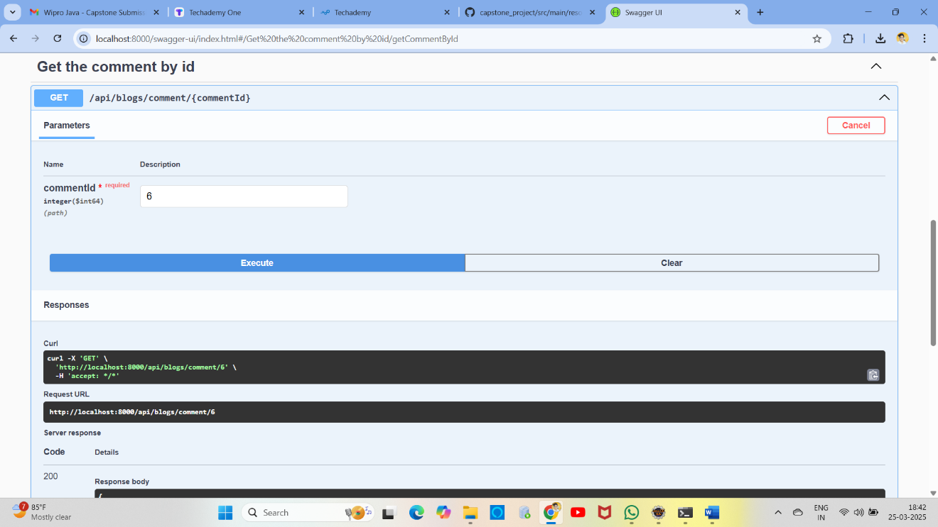

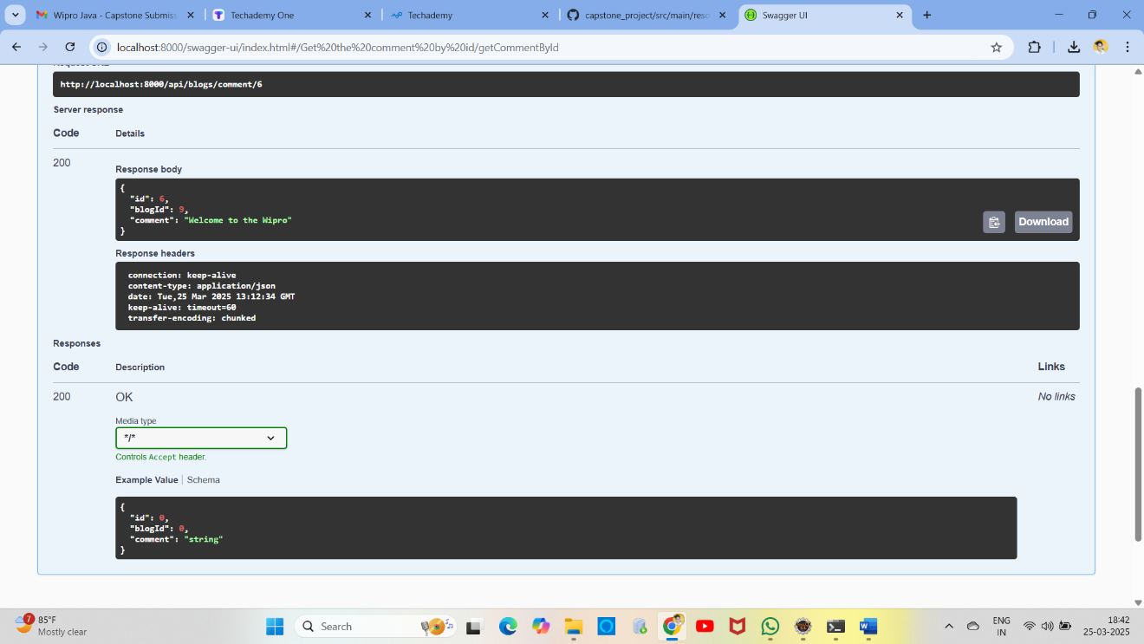

**8. Get All Comments Based on Blog Id (GET / api/blogs/{blogsId}/comments**

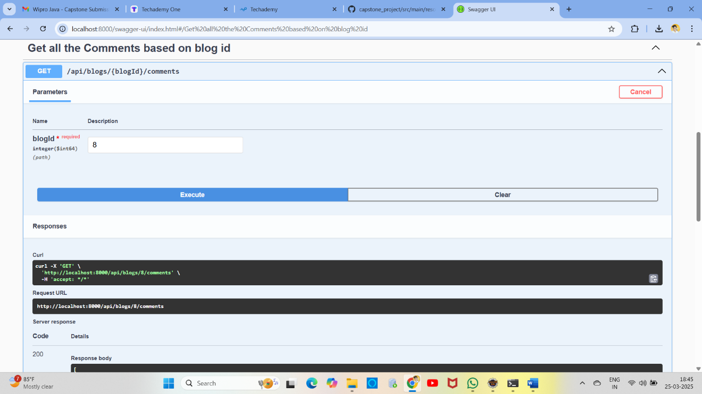

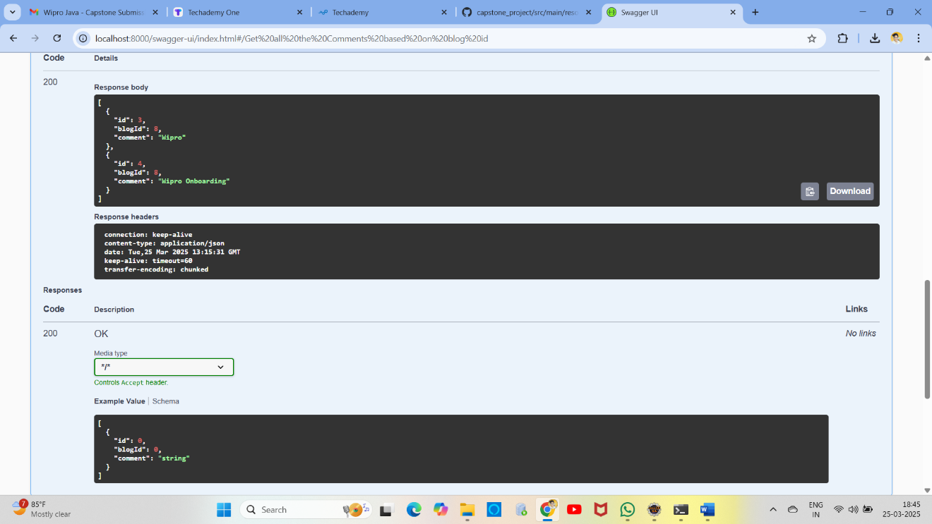

## Swagger API Screenshots – Negative Test Cases

1. Create Blog (POST /api/blogs) - Adds a new blog post.

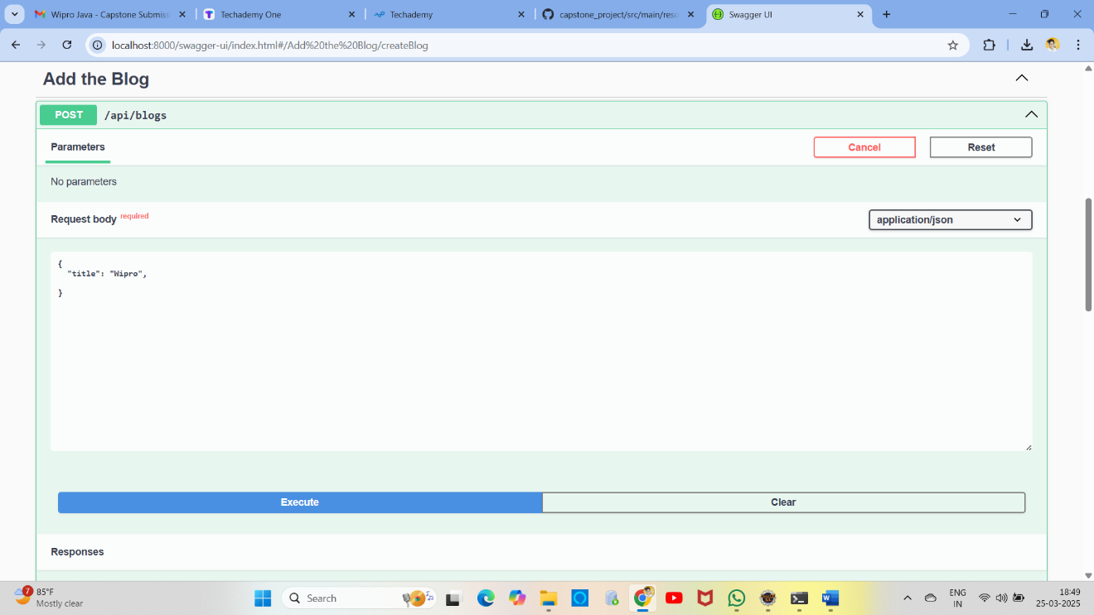

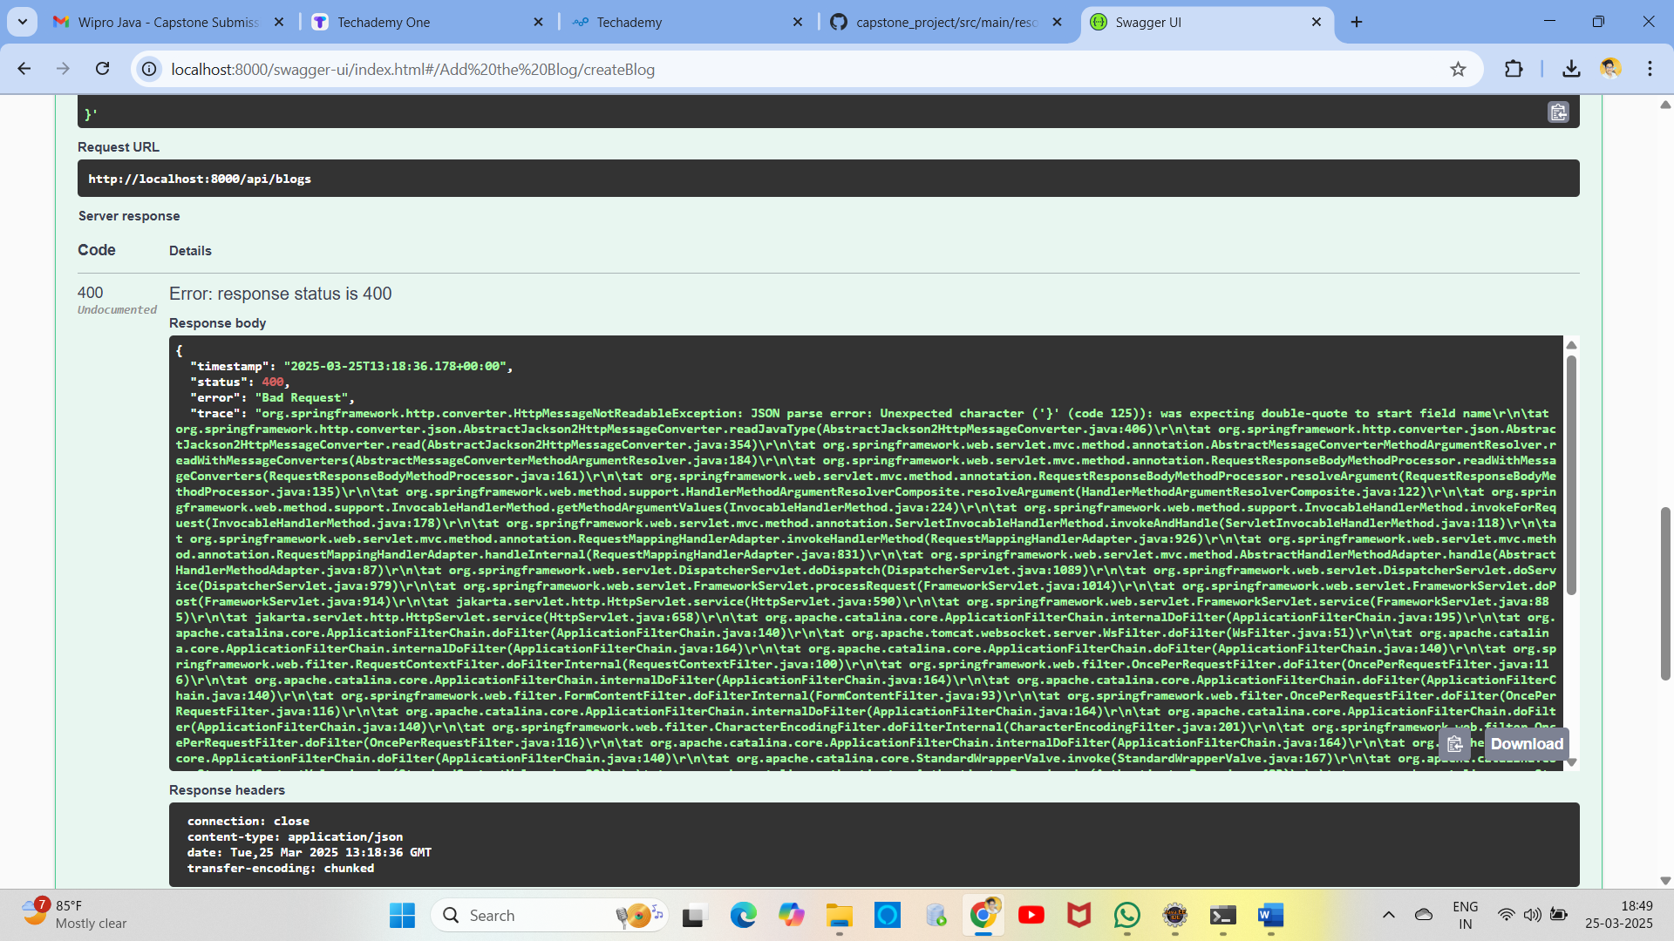

**"content|Content must not be blank",**

**"title|Title must not be Blank"**

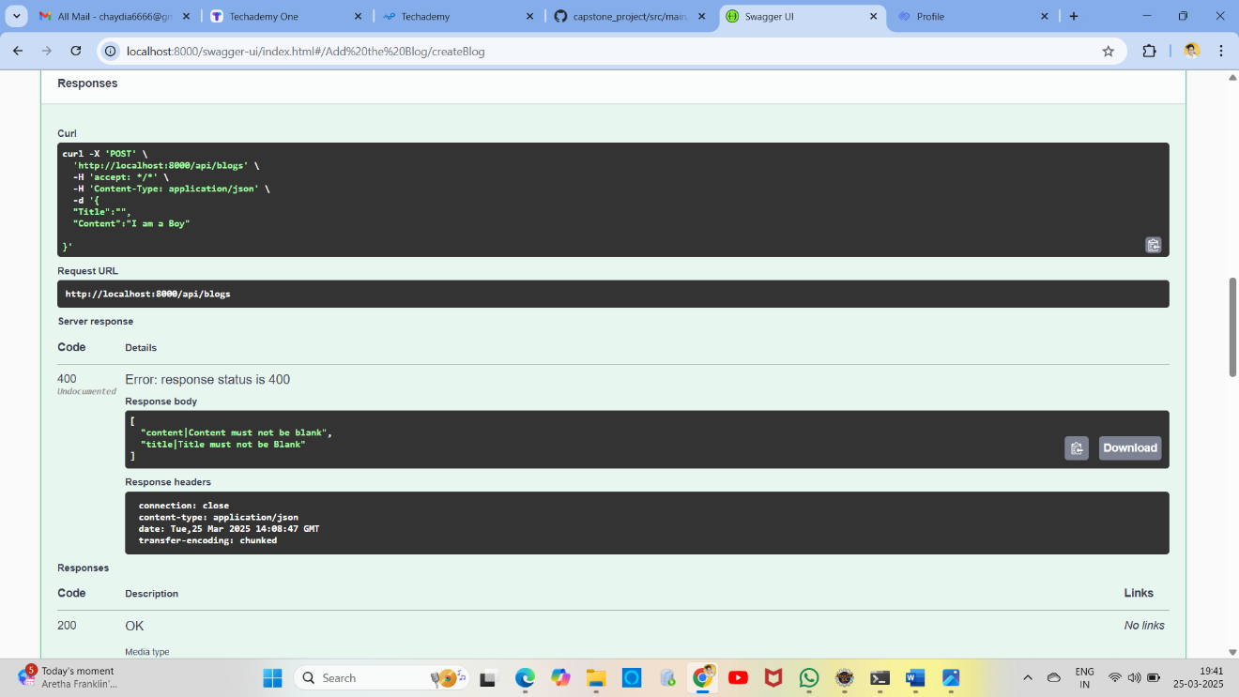

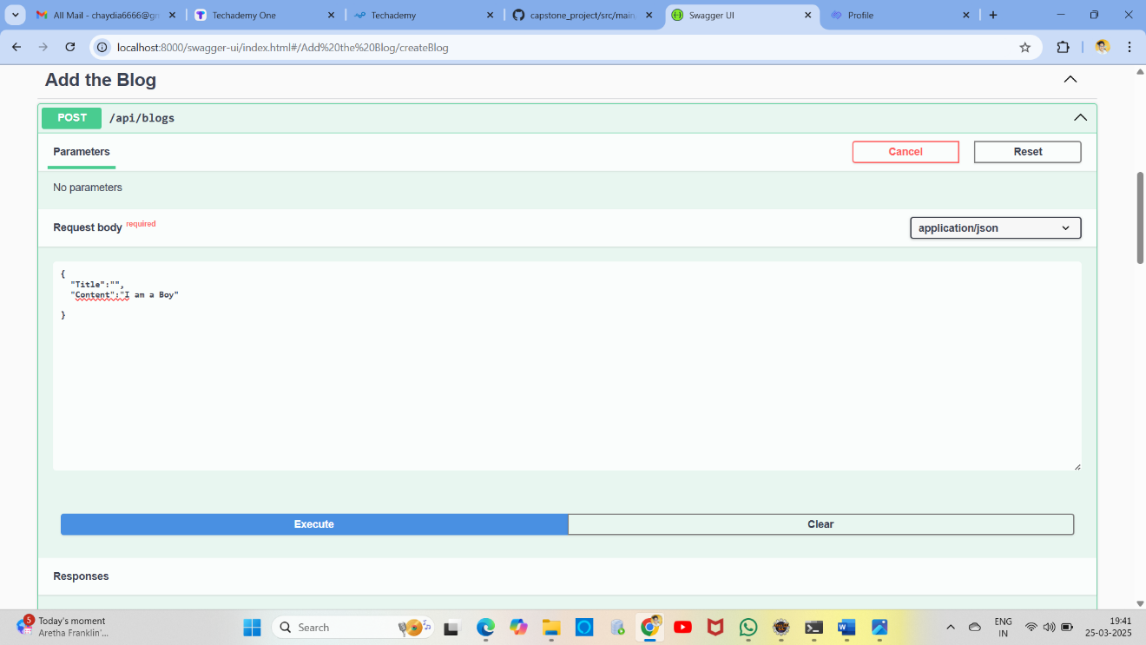

**2. Get Blog By ID (GET /api/blogs/{id}) - Retrieves a blog by its ID.**

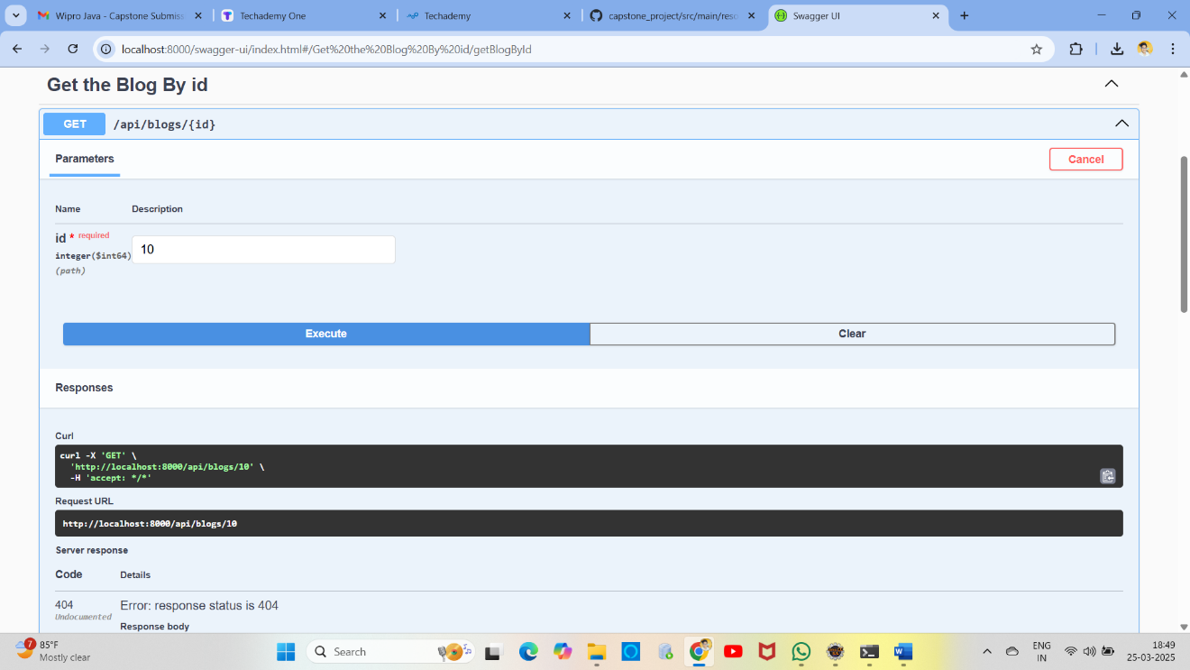

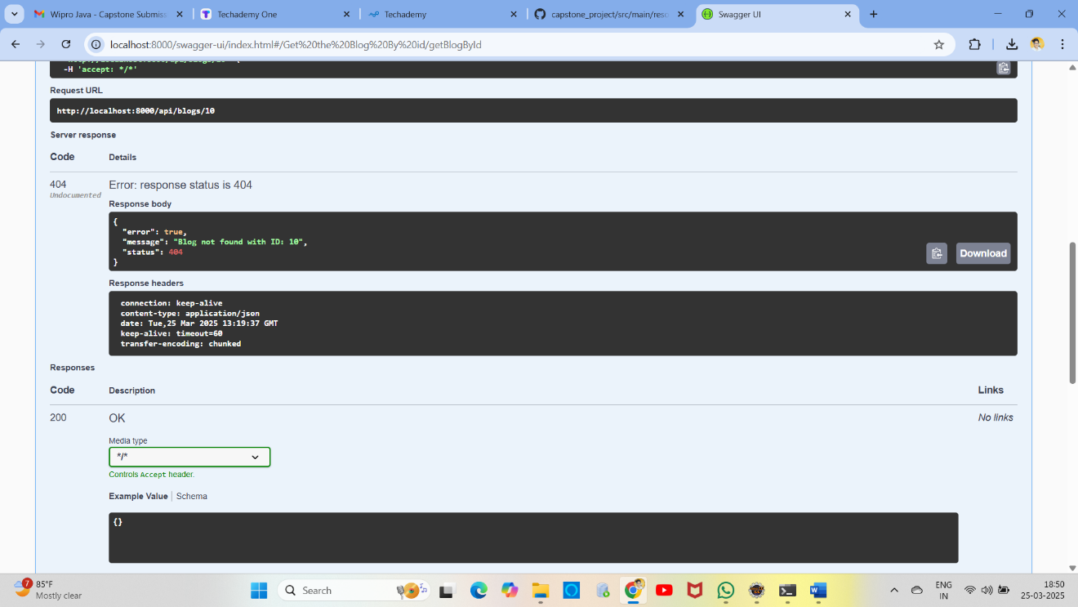

**3. Update Blog (PUT /api/blogs/{id}) - Updates an existing blog post.**

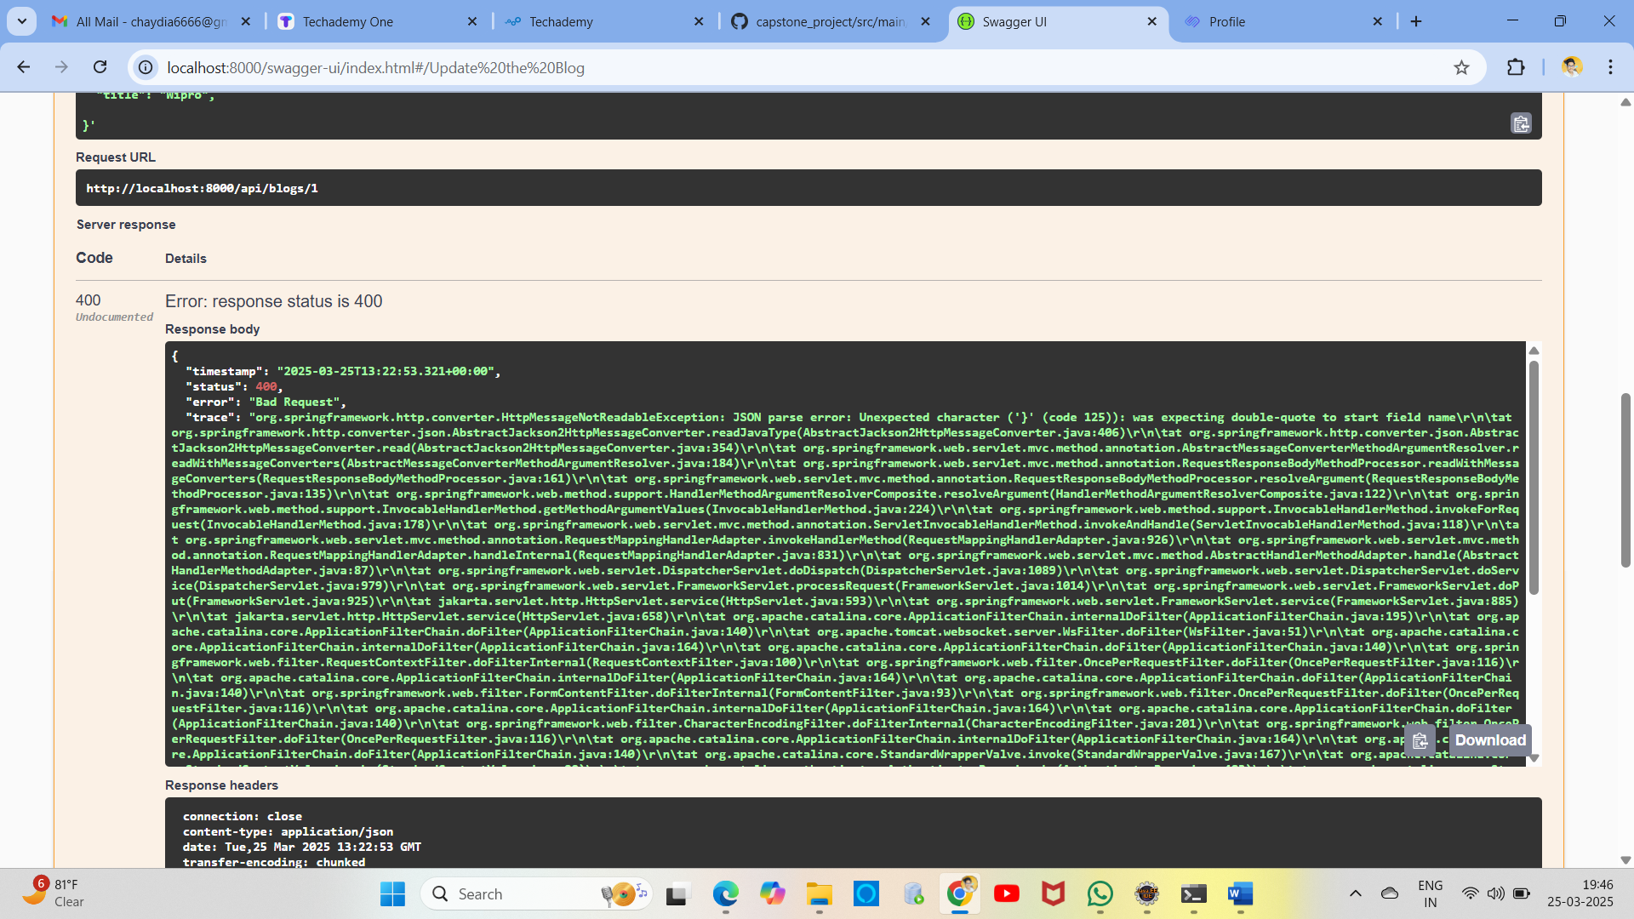

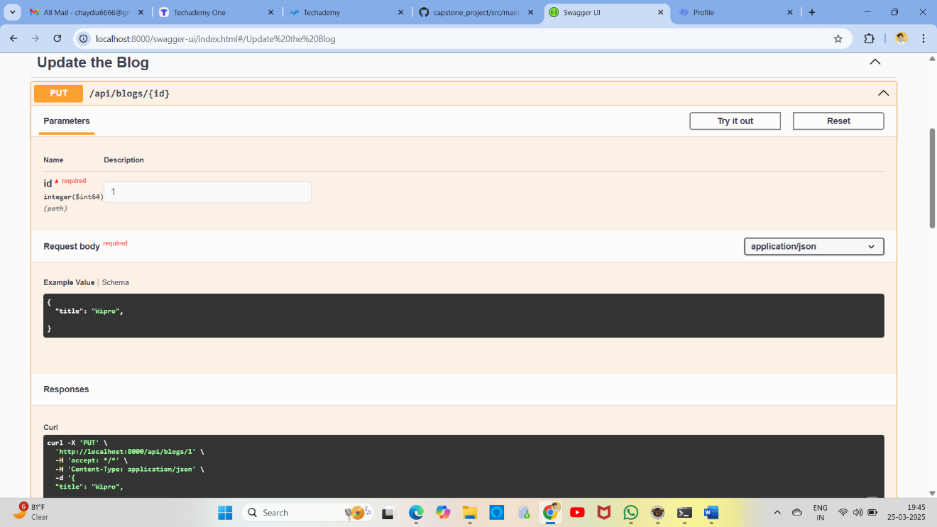

**4. Delete Blog (DELETE /api/blogs/{id}) - Deletes a blog post.**

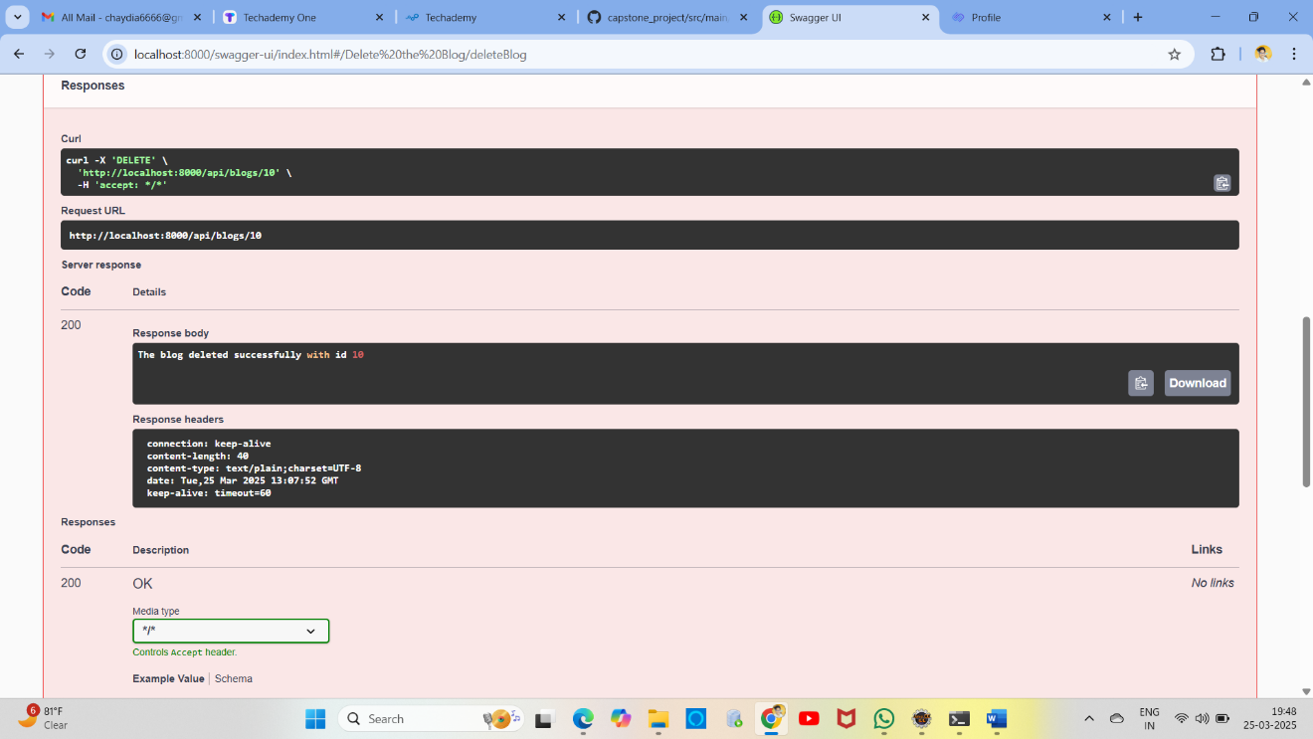

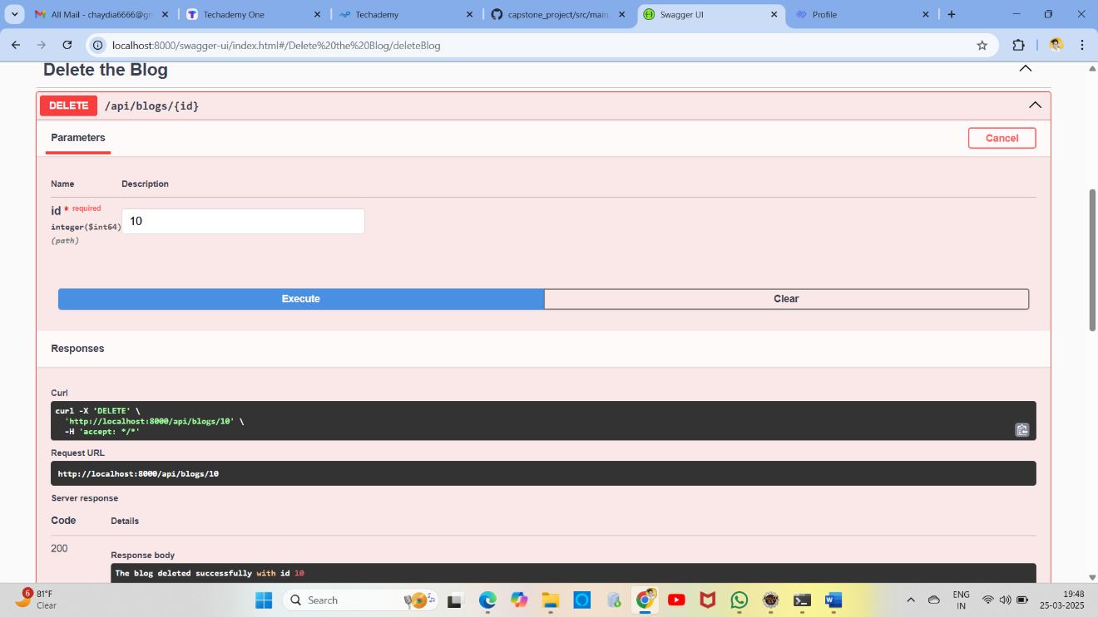

**6. Post Comment (POST /api/blogs/comment) - Adds a comment to a blog.**

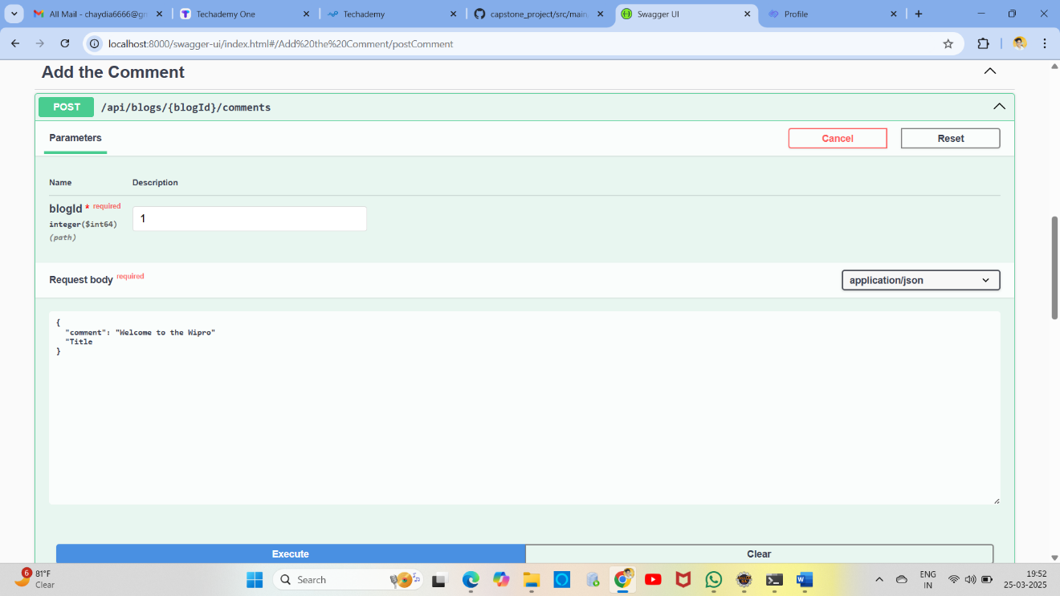

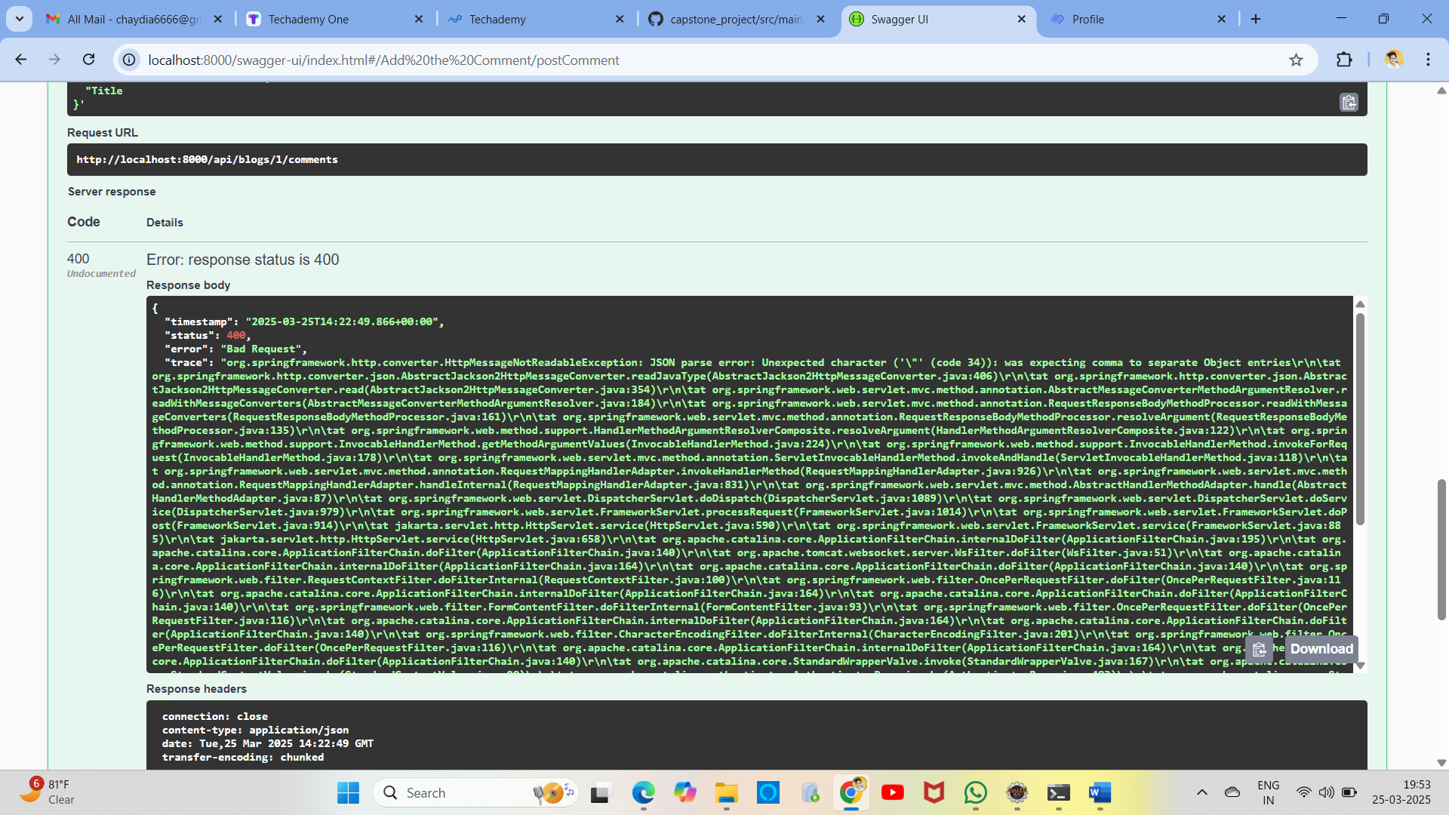

**7. Get Comments (GET /api/blogs/comment?blogId={id}) - Retrieves comments for a blog.**

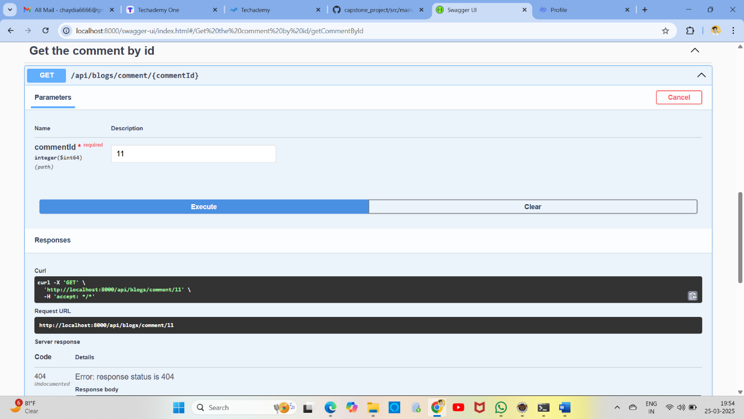

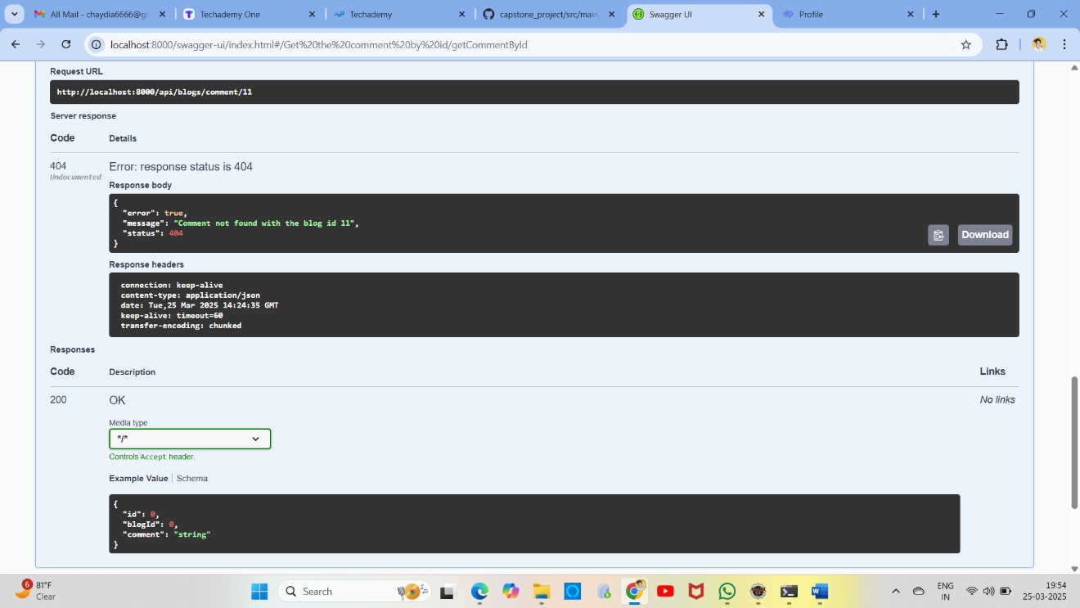

8. Get All Comments Based on Blog Id (GET / api/blogs/{blogsId}/comments ( Optional)

